CENWP-OD-B 06 July 2023

MEMORANDUM FOR THE RECORD

SUBJECT: 23BON044 MFR WA Shore UMTJ RB2 Pacific Lamprey Mortalities

On 06 July, Bonneville Fisheries discovered two adult Pacific Lamprey mortalities in the UMTJ Rest Box 2 (UMTJ RB2) of the Washington Shore Lamprey Passage System. The fish was scanned for PIT tags, inspected, and returned to the river.
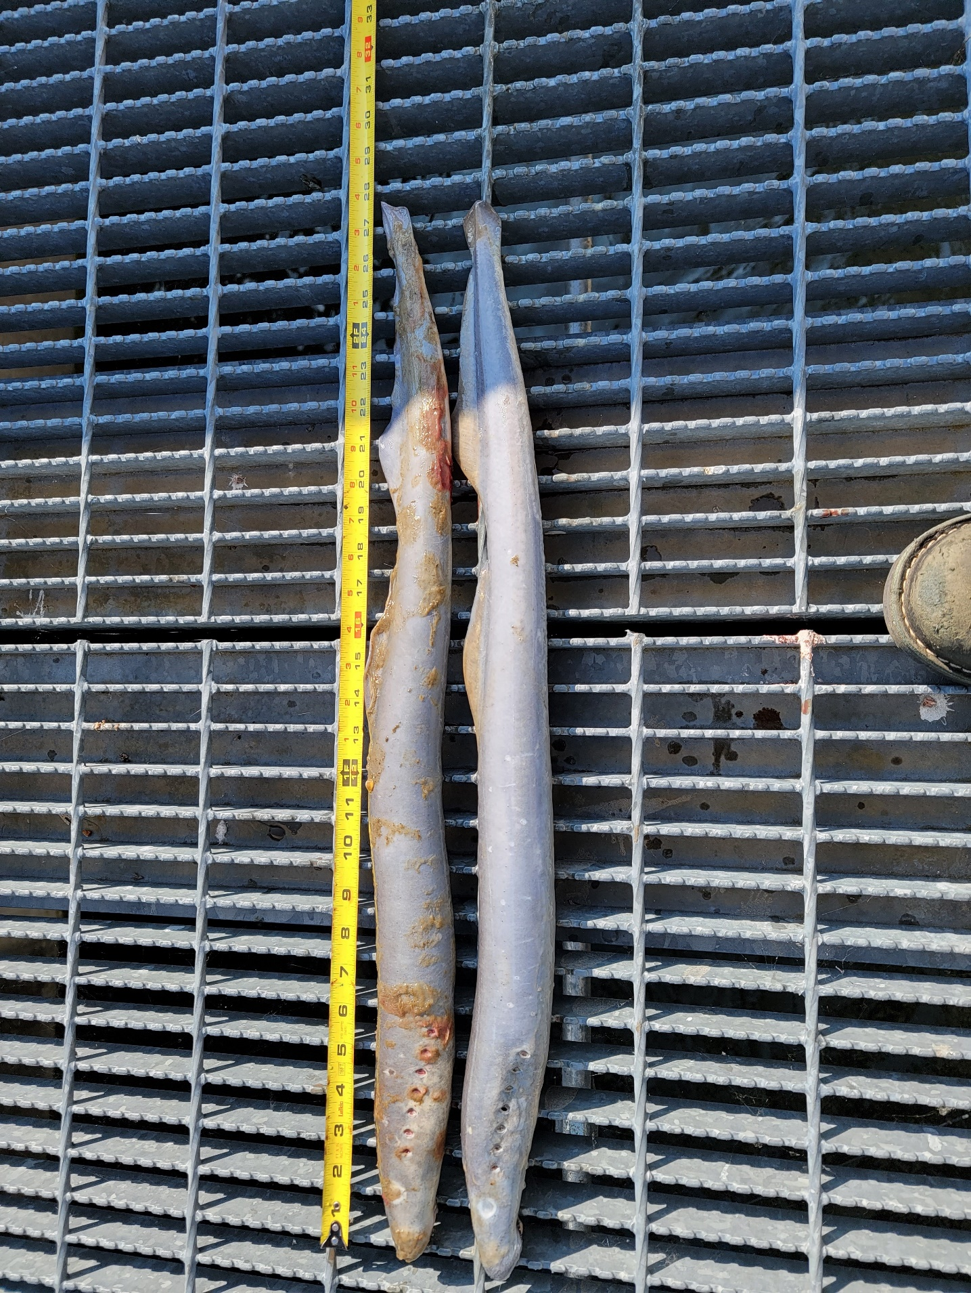

- Species – Pacific Lamprey (Entosphenus tridentatus)
- Origin – Unknown
- Length – In descending order: 70.8 cm, 70.5 cm
- Marks and tags – None
- Marks and Injuries found on carcass – None
- Cause and Time of Death – Unknown
- Future and Preventative Measures – None

Sincerely,
Bonneville Project Fisheries

